1. Introduction
This report presents the planning, design, and development process of the MAJOR CHEM PTY LTD website. MAJOR CHEM PTY LTD is a chemical manufacturing company that specializes in producing quality cleaning products such as dishwashing liquids, laundry detergents, and surface cleaners.
The purpose of developing the website is to create an online presence for the company, promote its products, provide information to customers, and improve communication between the business and its target audience. The website was designed to be visually attractive, user-friendly, and responsive across different devices.
The report discusses website specifications, site organization, page templates, development technologies, testing procedures, and future recommendations.
2. Website Specifications
Objectives
The objectives of the MAJOR CHEM website are:
- To promote the company's products and services.
- To increase brand awareness.
- To provide company information to customers.
- To improve communication between the company and customers.
- To create a professional online presence.
Target Audience
The target audience for the website includes:
- Households
- Cleaning companies
- Retail businesses
- Industrial customers
- General consumers
Website Type
The website falls under the category of:
- Business website
- Product marketing website
- Informational website
3. Information Design and Taxonomy
Information design refers to how information is organized and presented on the website.
The website uses a clear navigation structure that allows users to easily locate information. A navigation bar is placed at the top of every page to improve accessibility and user experience.
The website contains the following pages:
- Home Page
- About Us Page
- Products Page
- Contact Page
- Feedback Page
4. Site Map
The site map below shows the organization of pages within the website.
HOME
|
------------------------------------------------
| | I I
ABOUT US PRODUCTS CONTACT FEEDBACK
Insert Site Map Screenshot Here
5. Wireframes and Page Template Design
Wireframes were designed to provide a visual representation of the page structure before development began.
The following wireframes were created:
- Home Page Wireframe
- About Page Wireframe
- Products Page Wireframe
- Contact Page Wireframe
- Feedback Page Wireframe
The page template consists of:
- Header section
- Navigation bar
- Main content area
- Images and product cards
- Footer section
Insert Wireframe Screenshots Here
6. Technical Brief
The following technologies and tools were used during development:
Tool | Purpose
HTML5 | Website structure
CSS3 | Website styling
Bootstrap | Responsive design
JavaScript | User interaction
Visual Studio Code | Development environment
GitHub Pages | Website hosting
GIMP/Canva | Image editing and creating wireframe
Bootstrap was used to create a responsive layout that automatically adjusts according to different screen sizes.
7. Website Pages Description
Home Page
The homepage serves as the main landing page of the website and contains:
- Company logo
- Navigation menu
- Product previews
- Company overview
- Footer
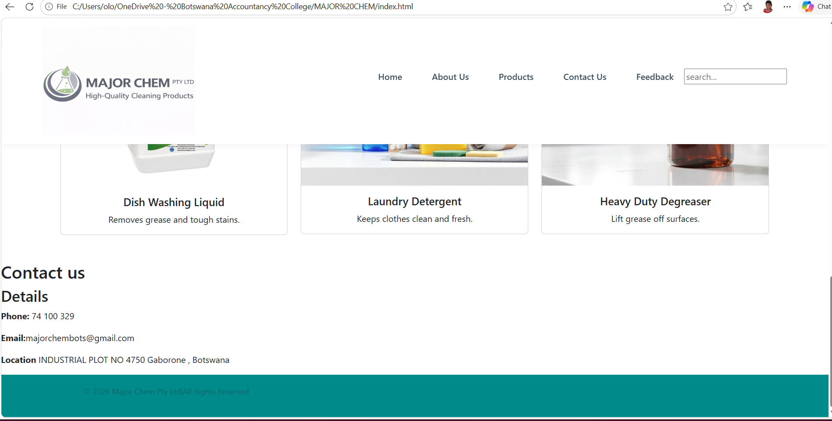
About Us Page
The About Us page provides information regarding:
- Company history
- Mission
- Vision
- Company values
- Product information
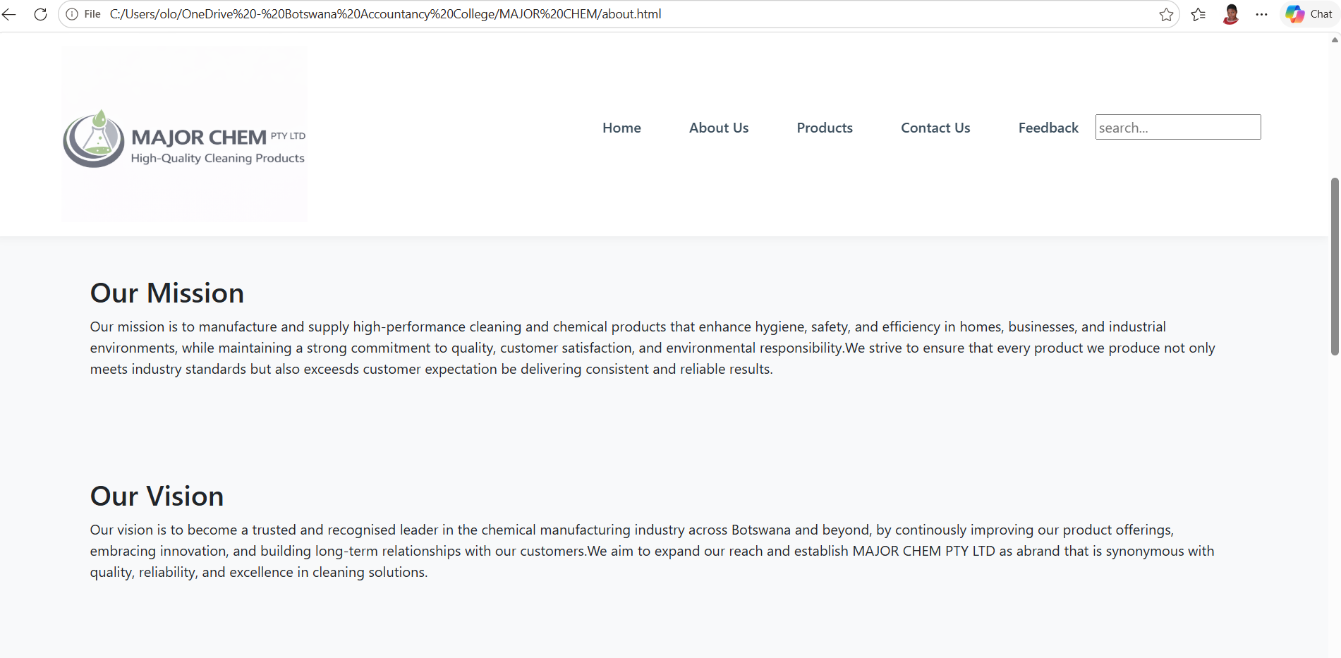
Products Page
The Products page displays various products offered by MAJOR CHEM PTY LTD including:
- Dishwashing liquid
- Laundry detergent
- Surface cleaner
Each product includes:
- Product image
- Product name
- Description
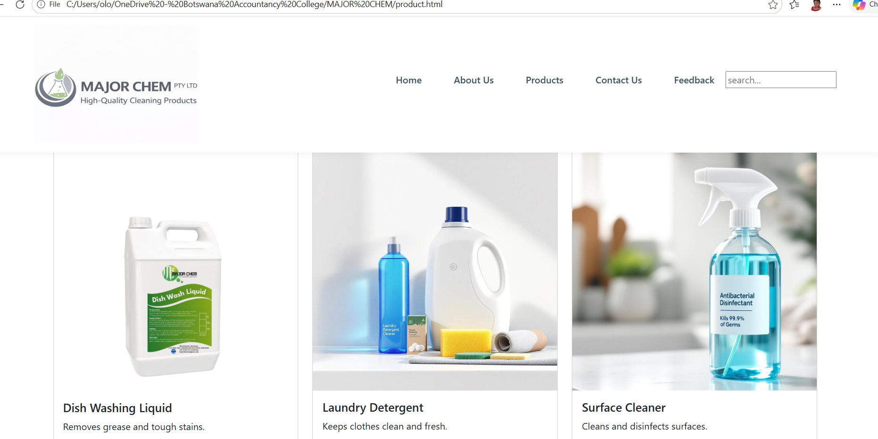

Contact Page
The Contact page contains:
- Company contact details
- Address
- Phone number
- Email address
- Departments
- Contact form
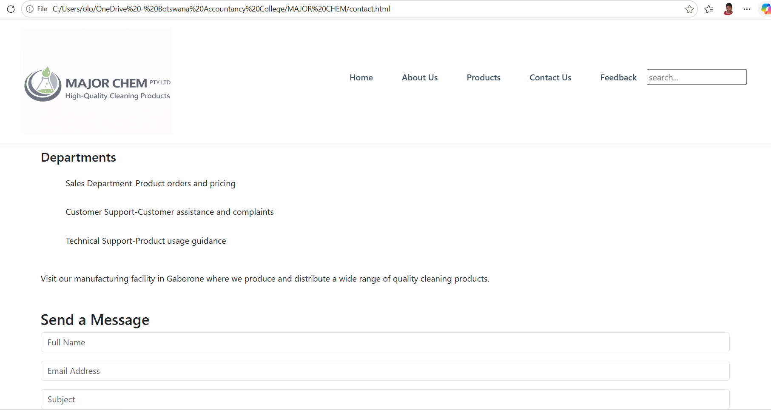
Feedback Page
The Feedback page allows customers to submit opinions and suggestions.
The page contains:
- Feedback form
- Product rating system
- Testimonials
- Privacy notice
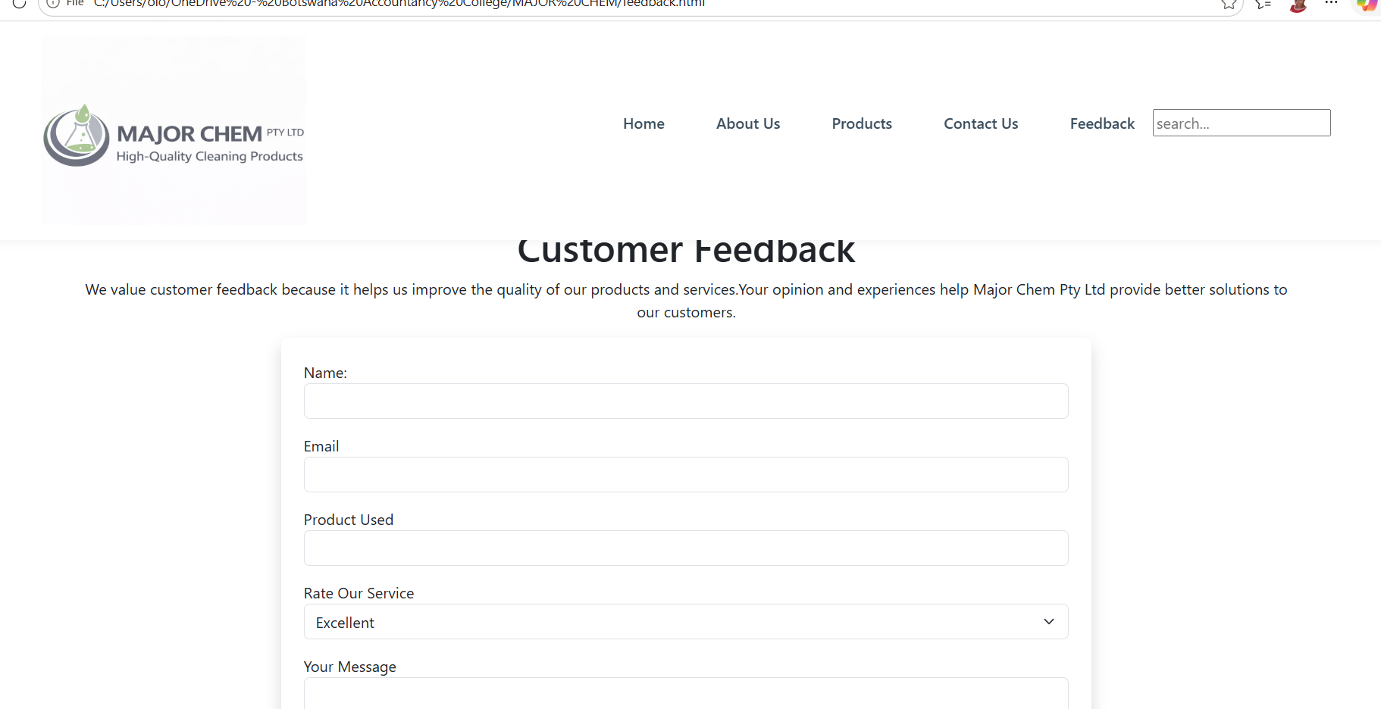
8. Quality Assurance and Testing
Testing was conducted to ensure proper website functionality.
Testing included:
Browser Testing
- Google Chrome
- Mozilla Firefox
- Microsoft Edge
Device Testing
- Desktop view
- Mobile view
Testing Results
The website:
- Loaded correctly
- Navigation links worked properly
- Images displayed incorrectly
- Forms functioned as expected
- Responsive design worked successfully
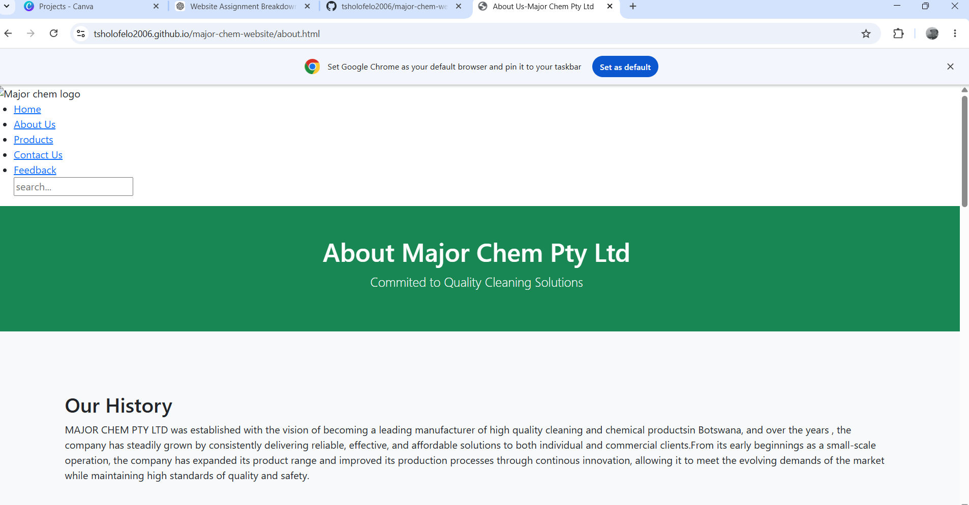

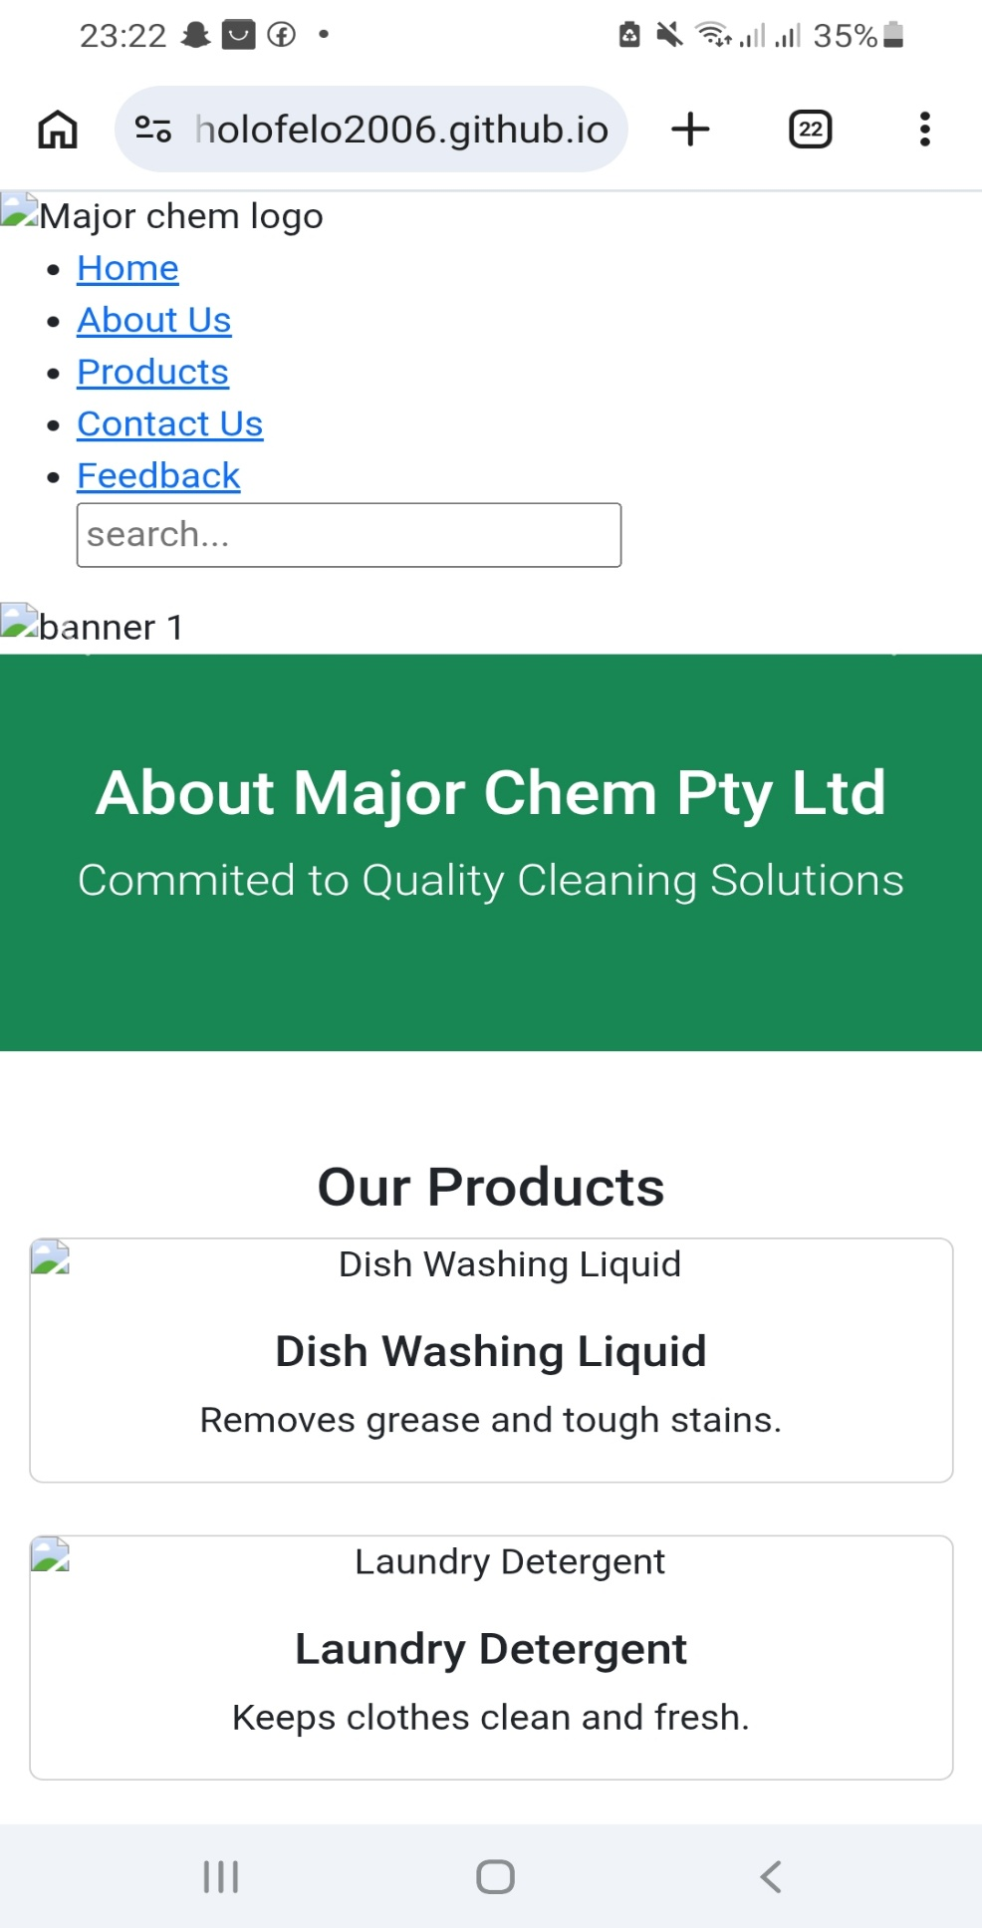

9. Publishing and Promotion
The website can be published using GitHub Pages.
Publishing steps:
- Create GitHub repository
- Upload website files
- Commit changes
- Publish using GitHub Page
Website URL: https://tsholofelo2006.github.io/major-chem-website/
10. Future Improvements
Future improvements that may be added include:
- Online ordering system
- User accounts
- Payment gateway integration
- Live chat support
- Product search functionality
- Improved animations and visual effects
11. Conclusion
The development of the MAJOR CHEM PTY LTD website successfully achieved its objectives of creating a professional and user-friendly online platform. The website effectively provides company information, promotes products, and improves communication with customers. Through proper planning, design, and testing procedures, the website offers a responsive and visually appealing experience across different devices.
Future improvements can further enhance functionality and improve user experience.
12. References
- W3Schools. (2024). HTML Tutorial. Available at: https://www.w3schools.com
- Bootstrap. (2024). Bootstrap Documentation. Available at: https://getbootstrap.com
- Mozilla Developer Network. (2024). HTML and CSS Documentation. Available at: https://developer.mozilla.org
- GitHub Pages. (2024). GitHub Pages Documentation. Available at: https://pages.github.com

